EduPro - Instructor Performance & Course Quality Evaluation
Introduction
Learning constitutes an inherent aspect of the human condition. Individuals acquire numerous competencies on a daily basis through diverse media, including experiences, mistakes, books, teachings, and related modalities. It represents a skill employed throughout the lifespan. It commences in childhood, when individuals are exposed to basic language, communication, executive functioning, literacy, numeracy, and social and emotional tools. Adulthood corresponds to the period in which careers are initiated and exposure to various real-world skills occurs. It marks the time when a greater proportion of learning occurs autonomously rather than through instruction from others—encompassing the acquisition of new skills, research, marriage, parenting, and related activities. The contemporary IT job market is undergoing substantial transformations on a continuous basis, which compels numerous IT professionals to engage in the constant learning of new tools every single day. Online learning constitutes one of the most prevalent modalities for acquiring any new trending skill in order to thrive within today’s volatile corporate environment.
There are several online platforms; the widely recognised ones include Udemy and Coursera, among others. Numerous courses are available across many domains (mathematics, physics, chemistry, computer science, and additional fields). These courses are delivered by many well-renowned instructors across the world. Notwithstanding this, not all courses possess equivalent quality, and not all instructors teach with equal efficacy. Certain courses are so well-designed that they challenge students with regular assignments meeting a defined standard. The instructors associated with such courses explain concepts effectively in simple terms, accompanied by straightforward examples. These courses and such instructors receive high ratings, which encourage the online learning platform to promote them extensively so that numerous new students may enrol in the course and preferentially select such instructors. There exist certain courses that are poorly designed—they either fail to provide sufficient assignments or explain concepts in a manner that renders them highly complicated for students. The instructors responsible for such courses establish standards that are either excessively low or excessively high. Such courses and instructors receive very poor ratings and are no longer preferred by new learners; these courses are no longer promoted on the platform. This project is concerned with conducting an in-depth examination of the course and instructor data on the EduPro learning platform and deriving significant insights from them.
Problem Statement
EduPro constitutes an online learning platform that offers several online courses across multiple disciplines. Individuals who enrol in these online courses are generally students, job seekers, researchers, professors, entrepreneurs and industry professionals. They do so in order to acquire new knowledge and upskill themselves so that they can meet the demands of their jobs that are constantly evolving. For example, a researcher might require knowledge on a certain topic if it is necessitated by their research. One source of knowledge can be to search the internet or watch videos on YouTube, but they might not constitute reliable sources. Online courses can assist this person in learning the topic very effectively. Let us consider another example. A data analyst possesses a strong command of Power BI for data visualisations and has utilised the tool for several projects. The upcoming project requires Qlik Sense for designing dashboards and reports, but the person does not possess any knowledge of the tool. There are YouTube videos, but they do not provide any deep-dive explanation of how such a tool needs to be utilised. So, this person needs to enrol in an online course that provides detailed explanations and regular assignments. In this manner, learners utilise the EduPro learning platform to acquire new knowledge in domains in which they have no prior knowledge, but their current circumstances expect them to possess it.
EduPro seeks to evaluate how effectively its platform is being utilised. This involves the number of users signing up for specific courses, how engaged and satisfied the users are with the courses of which they form a part, how much time is taken to complete a course and whether it is being completed within the expected time, how well the teachers are teaching, and much more. These metrics are necessary to assess how the platform is being utilised. This is because, based on these metrics, EduPro can implement certain measures to make its learning platform popular, thereby contributing to its growth. Currently, EduPro requires information on the following four:
- Which teachers make a consistent record of teaching courses of high quality?
- Do teachers with high experience deliver high-quality courses?
- Are there any course categories that depend on the quality of the instructor?
- How is teaching performance distributed across the platform?
In order to get clarity on the above four questions, EduPro expects us to answer five key analytical questions and the corresponding key performance indicators (KPIs) that answer the questions:
Key Analytical Questions | Key Performance Indicators (KPIs) | Meaning of KPI
What is the overall distribution of instructor ratings? | Average Teacher Rating | Measures the average rating received by instructors across the platform.
Do instructors with more experience receive higher ratings? | Experience Impact Score | Measures the relationship between instructor experience and teacher ratings.
Is there a relationship between Teacher Rating and Course Rating? | NA | NA
Which expertise areas consistently deliver high-quality courses | Average Course Rating, Rating Consistency Index | Average Course Rating - Measures the average course rating within each expertise area to identify consistently high-rated areas.  Rating Consistency Index - Measure of how consistent ratings are.
Are highly rated instructors associated with higher enrolments | Enrolment Influence Ratio | Measures the relationship between instructor ratings and student enrolments.

Dataset Provided
EduPro conducts several courses (both free and paid ones) at all levels of difficulty that span many disciplines. The details about every course on EduPro are stored in a table called Courses. An online course involves the teaching of concepts of the topic it offers, which is undertaken by a human being (teacher) with expertise in the subject related to the topic. For example, the “Introduction to Data Science” course is taught by a teacher who is specialised in Data Science. The teacher can be of any age and possess some years of experience in the specialised field. EduPro collected the details from all the teachers who teach courses on its platform into the “Teachers” table. Any online learning platform is utilised by people who desire to learn a new topic. EduPro is no exception. There are several users who are currently attending online courses on the platform. EduPro collected the details of all the users and stored them in the “Users” table. In order for these users to attend the courses, they initially need to sign up for the course. The sign-up process requires payment for the course if it is not free. EduPro decided to collect all the data on purchases users made for its courses in the “Transactions” table.
The following are the tables and their features:
Courses | Teachers | Transactions | Users
- Course ID  - Course Name  - Course Category  - Course Type  - Course Level  - Course Price  - Course Duration  - Course Rating | - Teacher ID  - Teacher Name  - Age  - Gender  - Expertise  - Years of Experience  - Teacher Rating | - Transaction ID  - User ID  - Course ID  - Transaction Date  - Amount  - Payment Method  - Teacher ID | - User ID  - User Name  - Age  - Gender  - Email

Data Analytics
Initially, all requisite libraries for data analytics are imported, as their absence would render subsequent analysis either infeasible or unduly complex. Libraries including NumPy, Pandas, Matplotlib, and Seaborn are therefore imported. NumPy and Pandas facilitate operations upon dataset values, whereas Matplotlib and Seaborn enable data visualisation.
The datasets required for the analysis are subsequently read. This step is essential, given that the entirety of the data resides therein; access must consequently be obtained in order to conduct the analysis. All four datasets under discussion are accordingly read and assigned to distinct variables.
To commence the analysis, consideration is given to the first key analytical question: “What is the overall distribution of instructor ratings?” This necessitates examination of the ratings of all individual instructors delivering courses on the EduPro platform, followed by their graphical representation in order to assess the distribution across the dataset. The Teachers dataset is employed for this purpose, as it contains the pertinent details of individual instructors. Prior to distribution analysis, null values and duplicates were examined; no null values were identified. Duplicate verification was then undertaken. The TeacherID column is excluded from this check, as it uniquely identifies each instructor; the possibility exists that distinct TeacherIDs may correspond to a single instructor. No duplicate entries were found within the dataset.
Given the absence of null values and duplicate records, the dataset is deemed clean, thereby permitting progression of the analysis. Instructor ratings are examined in order to evaluate their distribution. A Kernel Density Estimate (KDE) distribution plot is generated for Teacher Rating; the KDE plot constitutes one of the visualisation methods available within Seaborn. The first key analytical question further incorporates the evaluation metric of average instructor rating, defined as the mean of all individual instructor ratings. The average instructor rating is determined to be 3.12. The distribution approximates a normal distribution, albeit with non-uniformity along the left arm preceding the peak. The descending right arm subsequent to the peak exhibits uniformity. A pronounced concentration of instructors is observed in the vicinity of approximately 3.1, a value closely aligned with the average instructor rating. This indicates that the majority of instructors on the EduPro platform receive average ratings.
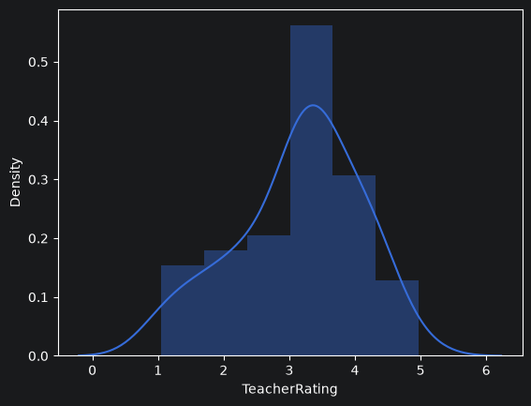

Average Teacher Rating: 3.12
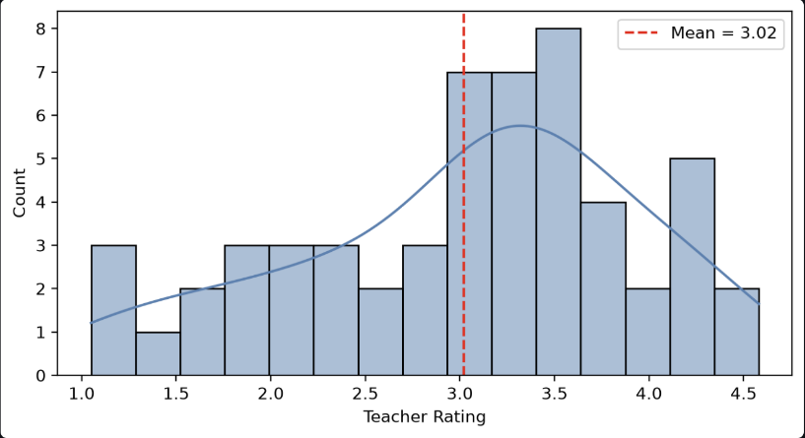
Within the Streamlit web application, selected filters are applied, encompassing instructor expertise, course category, course level, and the range of instructor ratings. This approach is adopted because users may require the principal evaluation metrics and associated results, as previously presented, to be confined to a restricted subset of options. For instance, upon exclusion of the “Machine Learning” teaching expertise while retaining all remaining options under the expertise filter together with all options under the remaining filters, the resulting distribution plot assumes the following form:

Here, average teacher rating is 3.02.
It is necessary to ensure that this purpose is fulfilled. Prior to this step, the Courses and Teachers datasets are considered and combined with the Transactions dataset. The Transactions dataset comprises the various course enrolments undertaken by users of the EduPro platform. The Courses dataset is combined with the Transactions dataset on Course ID to produce a resultant dataset, which is subsequently combined with the Teachers dataset on Teacher ID. Henceforth, this integrated dataset is treated as the principal dataset and is designated df.
In order to fulfil the objective of examining the distribution of instructor ratings under a restricted set of options, a function is constructed that incorporates code selecting specified values for the filters and correspondingly narrowing the dataset, thereby enabling the generation of a distribution plot for the resultant subset. The target feature is additionally supplied as an argument so that the distribution of that particular feature may be plotted. Should the distribution of instructor ratings be required, the corresponding feature name may be specified.
Discussion of the Streamlit application is deferred to a later section of this paper.
In a similar manner, the distributions of instructor age, work experience and related attributes may be examined; these analyses are available within the project Jupyter notebook. Instructor experience exhibits a decreasing distribution: a substantial number of instructors possess limited experience, and as experience values increase, the corresponding number of instructors declines. The number of instructors associated with each area of expertise may also be determined. Digital Marketing accounts for the highest number of instructors (11), while Marketing and Programming each contain only a single instructor. Exploratory data analysis may likewise be performed on the Teachers dataset in this fashion.
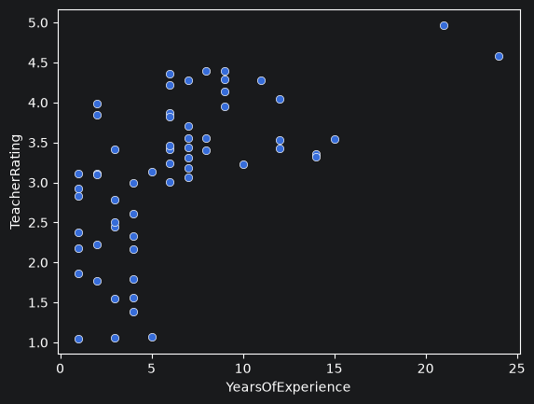
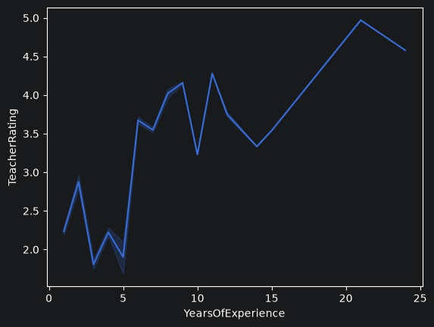
Attention is now directed to the second key analytical question: “Do instructors with more experience receive higher ratings?” The question encompasses two principal features—work experience and instructor rating—both of which reside within the Teachers dataset. This dataset is retained, restricted to three features: Instructors’ Name, Years of Experience and Instructor Rating. A simple scatter plot is generated in which each data point represents an instructor possessing a given combination of experience and rating. A line plot relating instructors’ experience to rating is additionally produced. The evaluation metric employed is the experience impact score, defined as the correlation between years of teaching experience and the ratings assigned to instructors.
Experience Impact Score: 0.598
The line plot exhibits an increasing pattern in instructor ratings relative to years of experience. The scatter plot, by contrast, comprises instructors with up to five years of experience who hold ratings across the full spectrum of levels, whereas those possessing longer teaching experience are rated very highly. The correlation coefficient between the two variables (the experience impact score) is 0.598, indicating a moderate positive relationship between teaching experience and ratings. Consequently, as teaching work experience increases, there exists a moderate probability that the instructor receives a higher rating, a pattern observable in the graphs. Conversely, shorter teaching experience does not necessarily imply a lower rating, given that a number of instructors with limited experience nonetheless hold high ratings.
Within the Streamlit application, selected filters are applied so that users may choose specific options and thereby obtain the relationship between teaching experience and the corresponding instructor ratings, together with the experience impact score, under a restricted spectrum of the selected options, in a manner analogous to the examination of the distribution of Instructor Rating.
Attention is now directed to the third question: “Is there a relationship between Instructor Rating and Course Rating?” Instructor Rating derives from the Teachers dataset, whereas Course Rating derives from the Courses dataset. The combined principal dataset (df) must therefore be employed. The ratings held by instructors and the ratings assigned to all courses are extracted, and a scatter plot is generated.
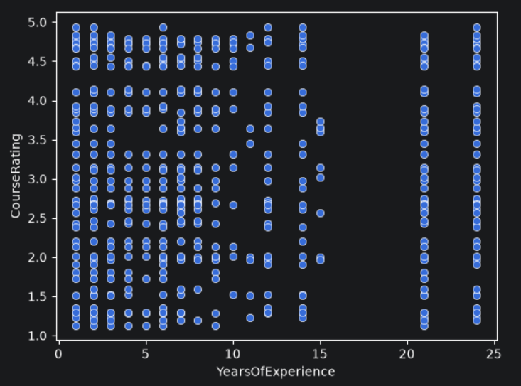

In the foregoing graph, each point represents the combination of a course offered on the EduPro platform together with its respective instructor. The graph essentially constitutes a matrix of points in which an instructor possessing a given number of years of experience delivers courses that receive ratings spanning the full range from low to high. This pattern indicates that scarcely any relationship exists between the two variables. The correlation between the teaching experience held by an instructor and course rating is likewise examined and is found to be 0.006, a value that is negligible. This result denotes the absence of any relationship between course rating and instructor rating.
Attention is now turned to the evaluation of course quality within each category. Such evaluation in turn facilitates the calculation of a key performance indicator—average course rating. Course categories, together with the ratings of courses belonging to those categories, are extracted from the principal dataset (df). The resultant dataset is retrieved and duplicate entries are eliminated. Line plots are subsequently constructed for each category, each plot depicting the ratings of all courses within that category.
Average Course Rating is defined as the mean of all course ratings within each category. Course ratings for the courses belonging to each category are taken and the average of those ratings is computed. A horizontal bar plot of these averages is then generated and presented within the Streamlit web application.
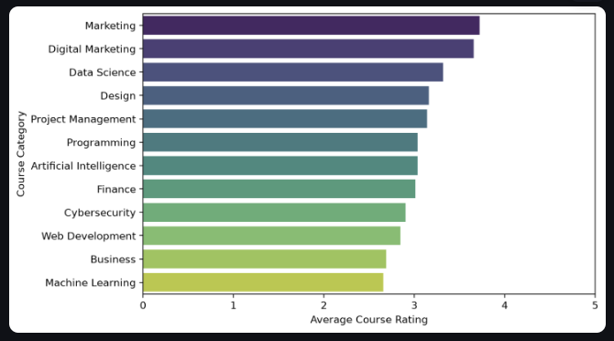

The quality of courses is likewise examined for each course level. Course ratings for the various courses belonging to each level are taken into account and their averages are computed. A vertical bar plot is subsequently constructed for this purpose.
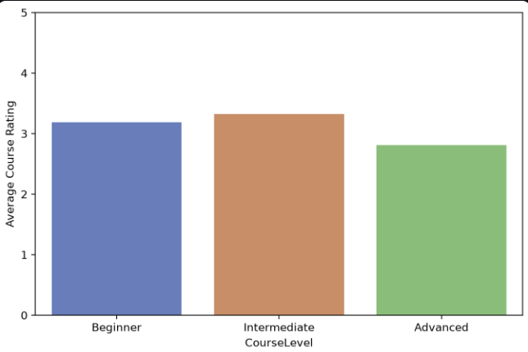

The correlation matrix of course categories and levels is likewise examined, with each cell presenting the correlation value between the two variables—namely, the ratings of courses within each category and those within each level. A heatmap is generated from this correlation matrix and is subsequently displayed within the Streamlit application.
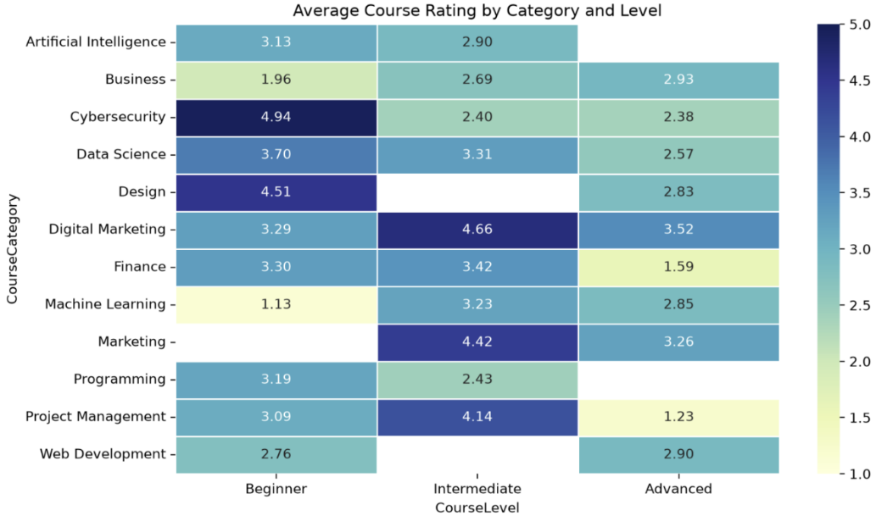

Calculation of the total number of enrolments for all courses taught by each instructor is next undertaken, stratified by instructor rating tier. This analysis addresses the fifth key analytical question: “Are highly rated instructors associated with higher enrolments?” Instructors are partitioned into three tiers according to their ratings. An instructor is classified as high-tier if the rating exceeds 4; mid-tier instructors hold ratings between 2 and 4; and low-tier instructors hold ratings below 2. A box plot is subsequently generated for each tier in order to examine the distribution of total enrolments within that tier.
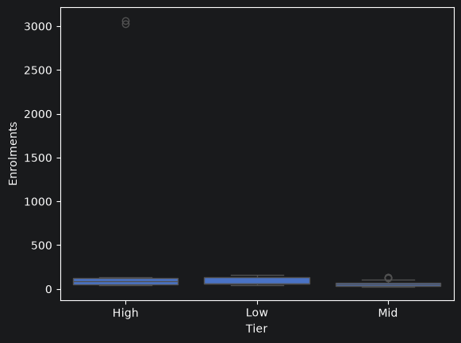

Inspection of the foregoing graph reveals that the boxes for all three tiers appear identical. This similarity is attributable primarily to the presence of two outliers among the high-tier instructors. Consequently, the two outliers associated with high-tier instructors are removed, after which the analysis proceeds. Line plots are then generated for those instructors together with their corresponding numbers of enrolments.
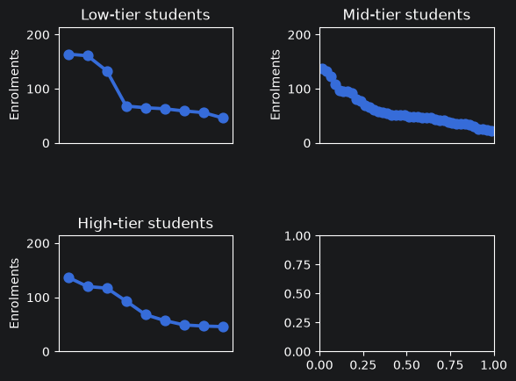

The following conclusions may be drawn:
- Among low-tier instructors, the majority deliver courses attracting fewer than 100 enrolments. Only three instructors teach courses that attract more than 100 enrolments.
- For mid-tier and high-tier instructors, a regulated pattern of course enrolments is observed; when the number of course enrolments by instructors is sorted in descending order, the resulting graph assumes the form of a regulated line graph, as illustrated above. Notwithstanding this pattern, enrolments remain below 150, with the exception of high-tier instructors, among whom two instructors account for more than 3 000 course enrolments.
An additional key performance indicator that may be considered is the enrolment influence ratio, defined as the correlation between instructor rating and number of enrolments. The enrolment influence ratio for the dataset is found to be 0.318; this value, however, incorporates the two outliers among high-tier instructors. Accordingly, the enrolment influence ratio is calculated separately for each instructor tier. The results are as follows:
Enrolment Influence Ratio for High-Quality Instructors: 0.83
Enrolment Influence Ratio for Mid-Quality Instructors: 0.03
Enrolment Influence Ratio for Low-Quality Instructors: 0.09
Inspection of the foregoing results indicates that the number of enrolments appears to be significantly dependent upon instructor quality solely in the case of high-quality instructors. For mid- and low-quality instructors, instructor rating exerts scarcely any influence upon enrolments.
Upon exclusion of the two instructors whose courses attract more than 3 000 enrolments (the outliers), the enrolment influence ratio for high-quality instructors becomes –0.36. This result implies that instructor quality exerts a negative influence upon the number of course enrolments.
Returning to the key analytical question—“Are highly rated instructors associated with higher enrolments?”—the answer is predominantly negative. Two highly rated instructors teach courses attracting more than 3 000 enrolments; the quality of the remaining highly rated instructors exhibits a negative correlation with the number of enrolments. For all other instructors, the number of enrolments is independent of instructor quality.
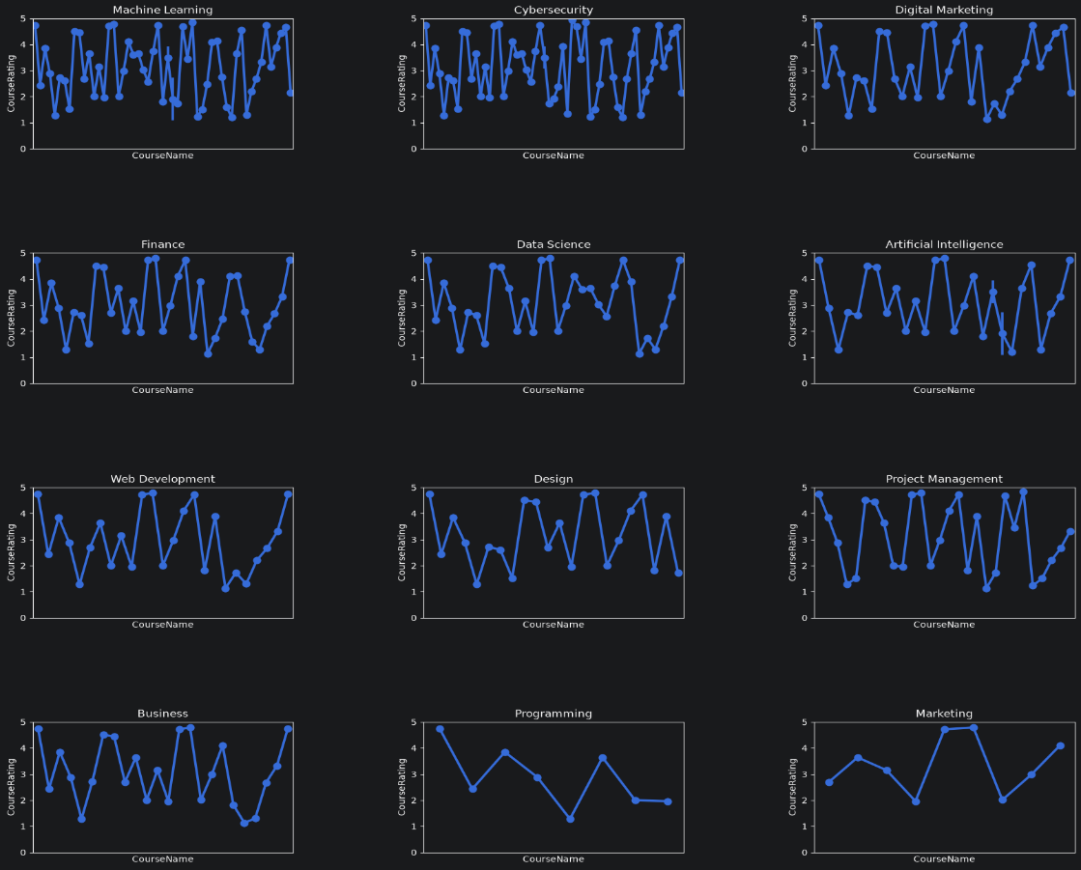
Analysis of course quality by instructor expertise is now undertaken. This examination addresses the fourth key analytical question: “Which expertise areas consistently deliver high-quality courses?” Line graphs are constructed to depict the ratings of the various courses associated with each instructor expertise area.

Each graph represents an instructor’s expertise domain. Course ratings are plotted for every course. It is observed that course ratings fluctuate with considerable frequency and magnitude. When the rating of one course is low, the rating of the subsequent course rises abruptly to a markedly higher value. This pattern indicates an absence of consistency in the delivery of high-quality courses within any expertise domain. Two evaluation metrics are additionally computed: average course rating and rating consistency index. The rating consistency index quantifies the degree of consistency among ratings and is defined as the standard deviation of the ratings of the various courses. Average course ratings across expertise areas range from 3 to 4, signifying that instructors in all domains deliver courses of above-average quality. The rating consistency indices are sufficiently low to demonstrate that no expertise area exhibits consistently high ratings. The sole domain for which the rating consistency index falls below 1 is Data Science.
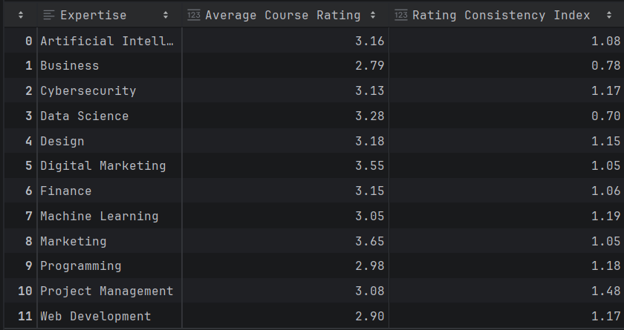

This concludes the examination of all key analytical questions.
An additional analytical step is now undertaken: the identification of those instructor domains in which teaching quality exerts the greatest influence. Line graphs are constructed for every expertise domain. Each line graph corresponds to a single expertise domain, with the plotted points representing the ratings of all instructors within that domain. Average Instructor Rating and Enrolment Influence Ratio may be calculated in this context.
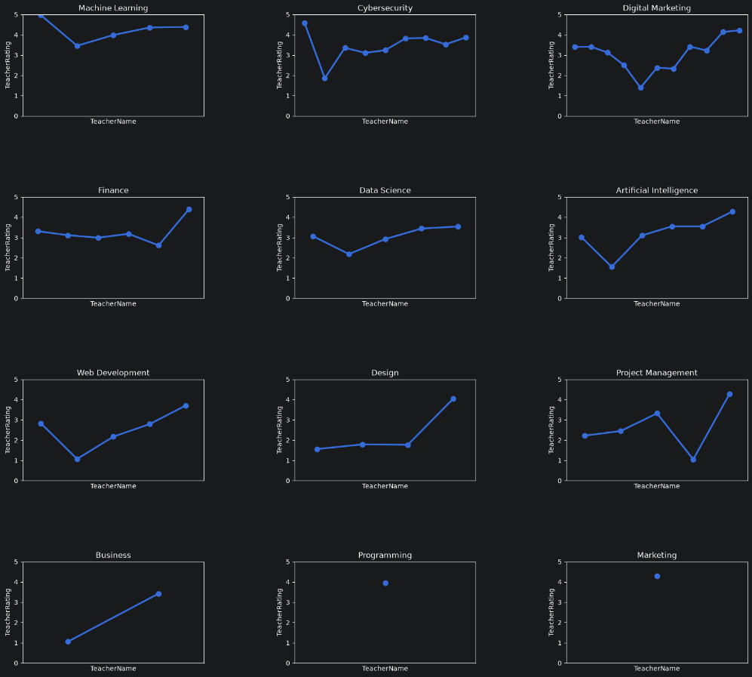

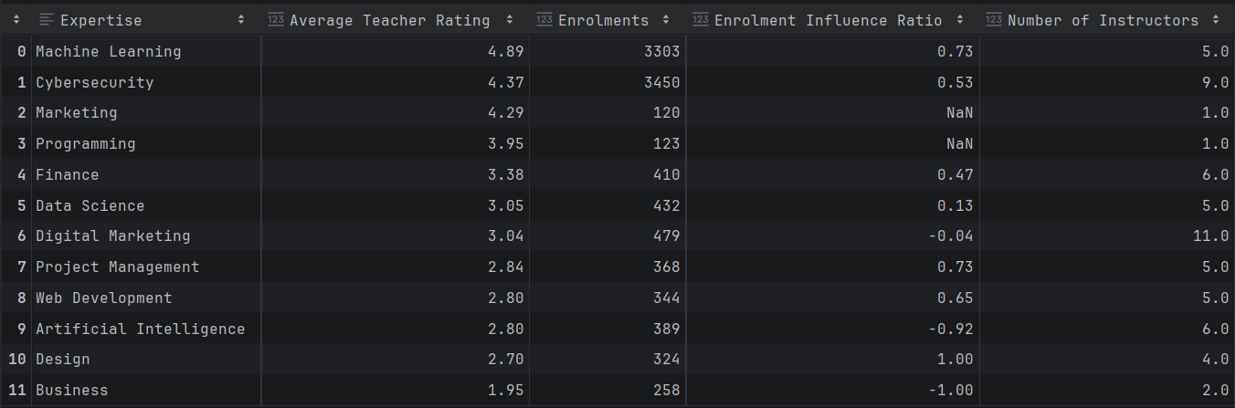

It is established that instructors deliver only a single Marketing course and a single Programming course. Two expertise domains emerge as those in which instructor quality exerts the greatest influence: Machine Learning and Cybersecurity.
The following expertise gaps or training needs are identified:
- Only one instructor is present in each of the Marketing and Programming domains. An increase in the number of instructors within these two domains is required.
- The majority of domains contain approximately five or six instructors each. The introduction of additional niche courses within these expertise domains is necessary in order to accommodate a greater number of instructors.
- Artificial Intelligence (AI) constitutes the sole domain in which course quality varies negatively with enrolments. Consequently, the number of enrolments in AI courses declines as instructor quality increases. This pattern diverges from real-world observations, given that AI represents a rapidly expanding technological domain. An expansion in both the number of courses and the number of instructors within the AI domain is therefore required.
A Streamlit web application is constructed to present all results derived from the analysis. The sole interactive elements incorporated are the filters for expertise, course category, course level and instructor rating range. Expertise denotes the areas of specialisation held by instructors. Course category refers to the domain to which each course belongs. Course level indicates the degree of difficulty associated with each course. Instructor rating range specifies the interval of instructor ratings to which the dataset is to be restricted. Users may select any option or combination of options from each filter. The principal dataset is thereby reduced to those rows that satisfy the selected options for the respective filter features, and the corresponding results are displayed within the web application.
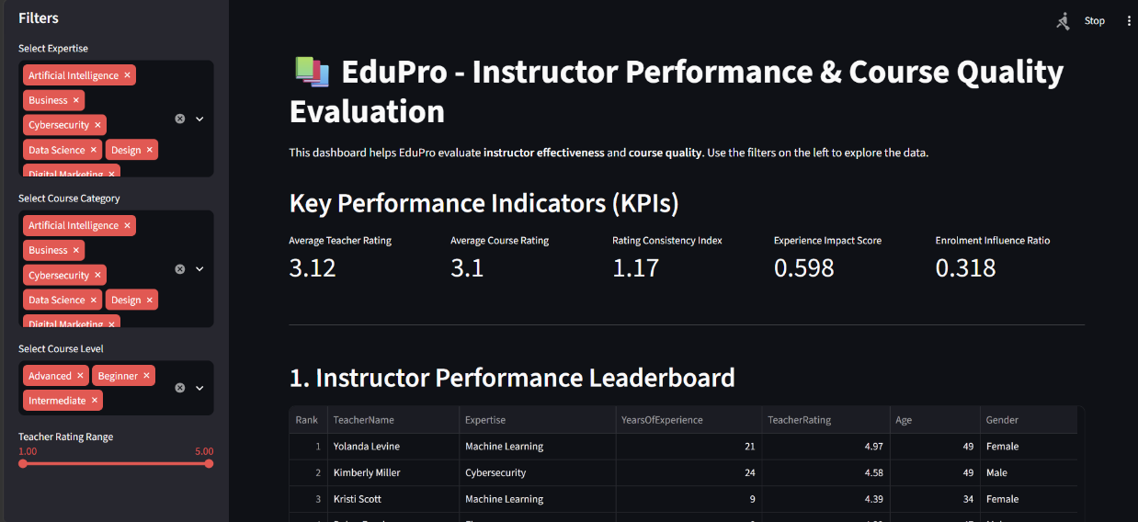

The following is the link to the Streamlit web application:
https://edupro-lqx9.onrender.com/
Recommendations
Teaching quality is highly variable. We observe both low quality instructors and those of higher quality in significant numbers.
Teaching experience does help an instructor to become a better instructor. This can be observed by teachers of longer experience holding better ratings. Teachers with longer experience also mentor juniors, which boost their quality.
There is no guarantee that a teacher of high quality teaches a well-renowned course – In order to improve learning outcomes, the course needs to be designed in the way that keeps learners constantly engaged. Content should be in such a way that users can easily grasp every concept.
Marketing and Programming domains have only one instructor each. More instructors have to be hired in these areas.
The domains with highest quality of teachers are Machine Learning and Cybersecurity. They deserve deserve priority quality-assurance attention.
High-quality instructors greater than 4.0 rating attract more students to enrol in their courses. This means that the high reputation of instructors lead to increase in choice of learners.
Conclusion
Currently, EduPro follows a very fragmented and subjective approach to evaluate instructors. The evaluation system needs to shift to a very clear, consistent and data-driven system. The KPIs, Streamlit dashboard, research paper, and executive summary provide practical tools to regularly assess teaching effectiveness, identify areas for improvement, and build trust in the platform.

